How To Enroll
Log in to your student portal at  MYCOLLEGE.LACCD.EDU | 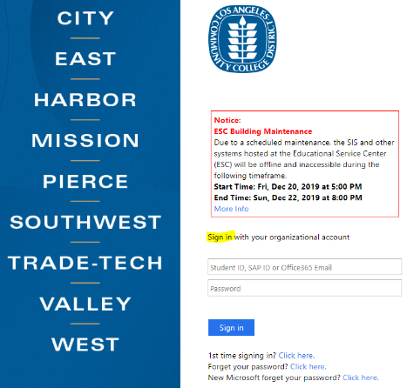
Click on “MANAGE CLASSES” | 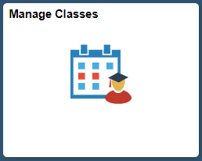
Click on “CLASS SEARCH AND ENROLL” | 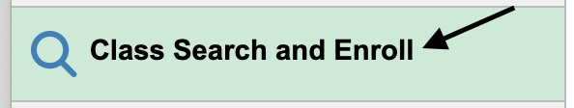
Click on the semester you wish to enroll in. | 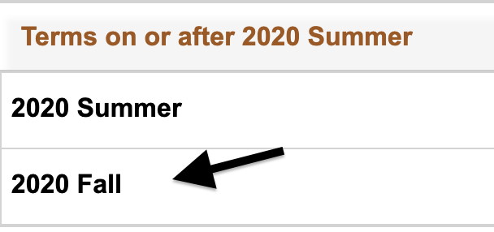
Under “SEARCH FOR CLASSES,” enter the COURSE NAME  - Ex: ASL 001, Psych 001, SOC 001, etc. | 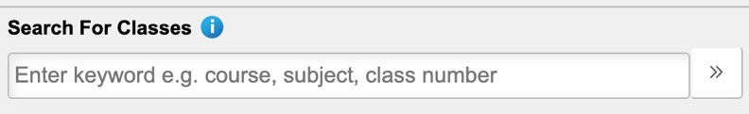
Exit out of “OPEN CLASSES ONLY”  Then, select the COURSE NAME | 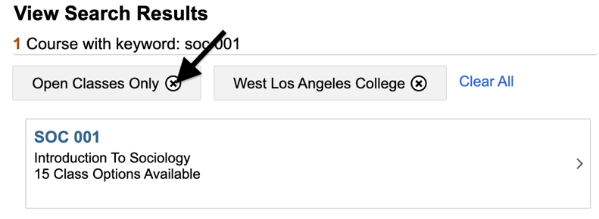  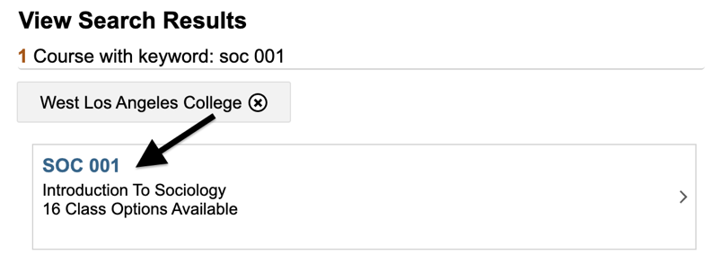
Choose a CLASS #  - A class # is also known as a section #  - Ex: Class#18348, Class#18349, Class#18350  Click on the row (not the blue link) | 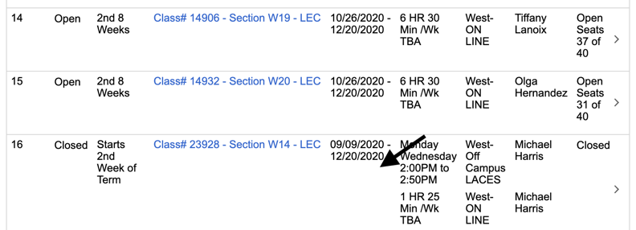
STEP 1: REVIEW CLASS SELECTION  - You should review the add, drop, and refund deadlines for each class by clicking on the blue link  - You can also find instructor emails by clicking on the blue link  Click “NEXT” | 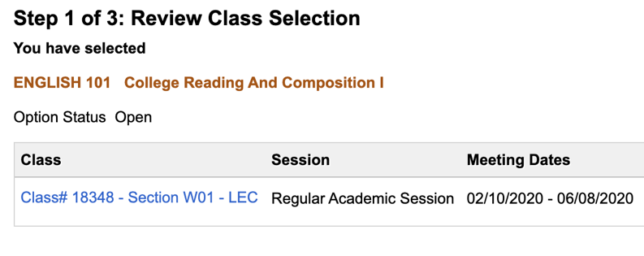
STEP 2: REVIEW CLASS PREFERENCES  - If the class is “Closed” or has already started, you will need to request a permission number from the instructor.  Click “ACCEPT” | 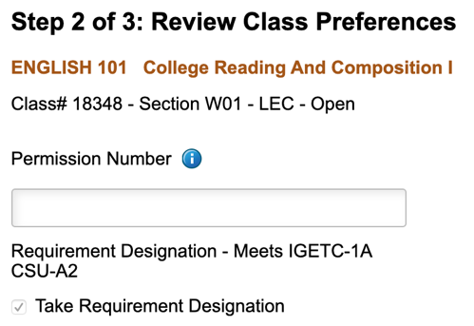
STEP 3: ENROLL OR ADD TO CART  Select “ENROLL”  Click “NEXT” | 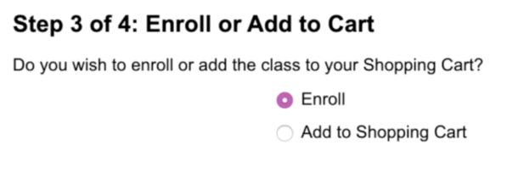

STEP 4: REVIEW AND SUBMIT  Click “SUBMIT” | 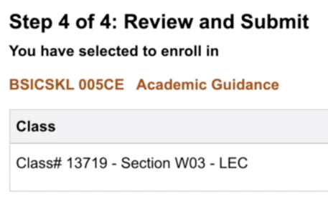
CONFIRMATION  Select “YES” | 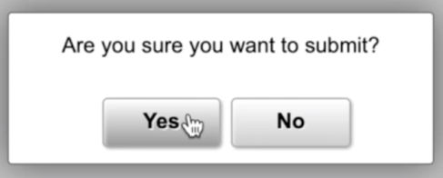
CONGRATULATIONS, YOU’RE ERNOLLED! | 